Grant Grummer

2/10/2021

Dazzelite User’s Manual

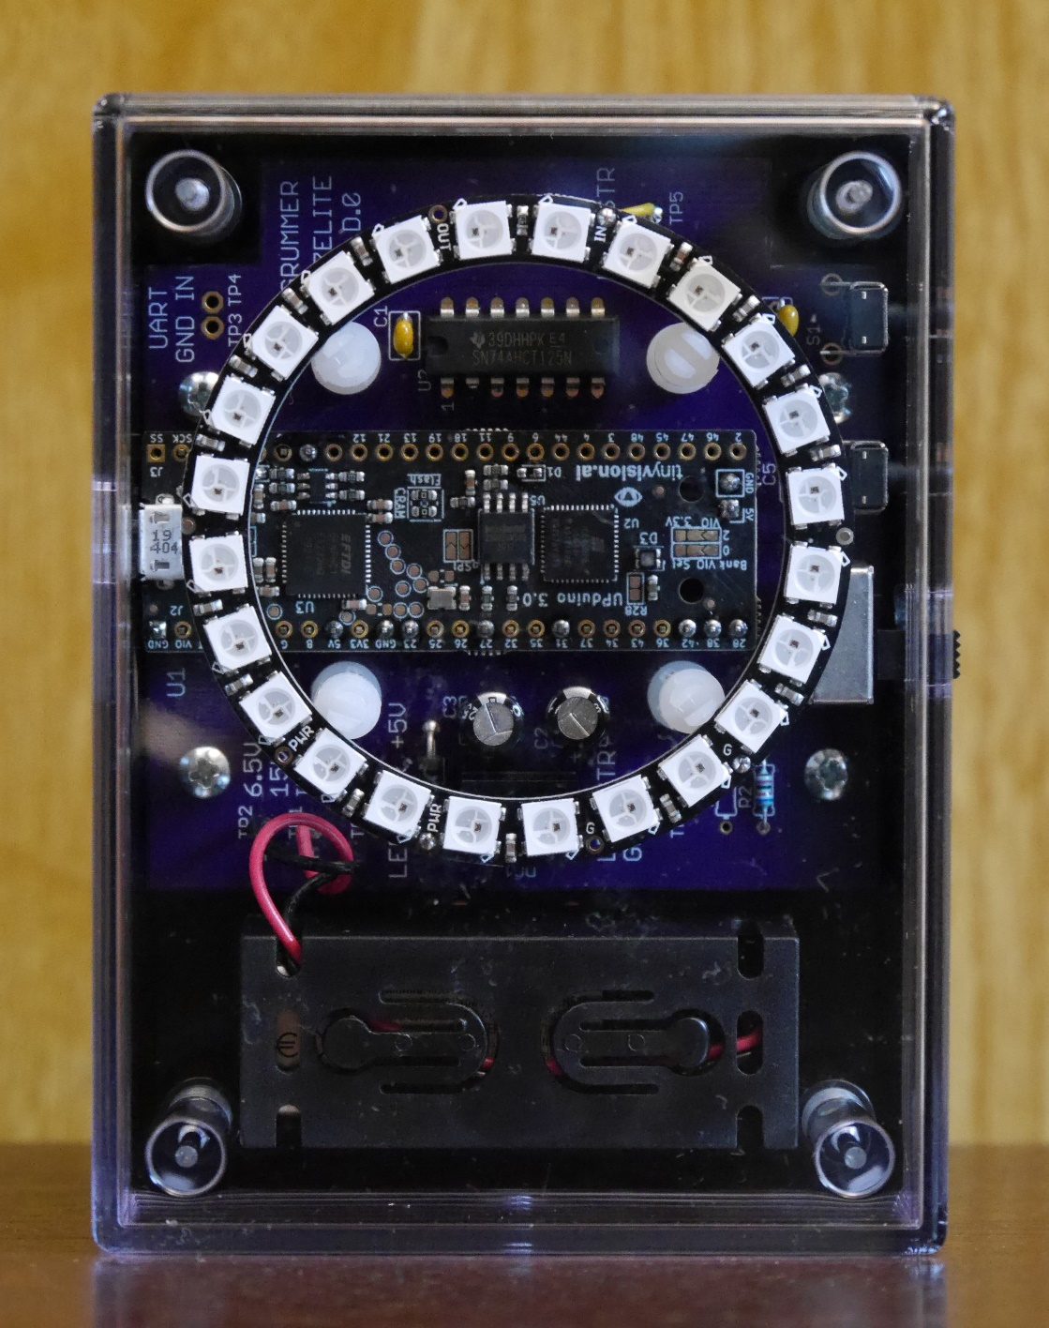

Revision: A.0

Table of Contents

Introduction 1

Dazzelite Design Environment 2

Building the Design 2

Custom Displays 3

Programming Dazzelite 5

Programmer Access Through Radiant 5

Standalone Programmers 6

Programming Steps 6

Instructions 7

Instruction 0: Blackout Display 7

Instruction 1: Delay 7

Instruction 2: Finish 7

Instruction 3: Set Random LED 8

Instruction 4: Set LED 8

Instruction 5: Chase 8

Instruction 6: Left to Right and Right to Left 9

Instruction 7: Fade In and Out 9

Instruction 8: Loop 10

Instruction 9: Set Color Palette 10

Instruction 10 (0xA): Reserved 10

Instruction 11 (0xB): Rainbow 11

Instruction 12 (0xC): Reserved 11

Instruction 13 (0xD): Automatic Timeout 11

Instruction 14 (0xE): Unused 12

Instruction 15 (0xF): Unused 12

Code Base 12

Block Diagram of Dazzelite Code 13

# Introduction

Welcome to the Dazzelite User’s Manual. Dazzelite can be built in many ways. One can build a version on a breadboard, a perfboard or a custom PCB. The perfboard and custom PCB versions can be mounted into a case, making the unit portable. This document is written for the custom PCB version, mounted into a beautiful, portable case with a built-in battery compartment.

Dazzelite uses a tri-color LED ring to produce different light displays. Dazzelite is programmable, so the displays are only limited by your imagination. No previous software knowledge is required. A set of default light displays along with an introduction to Dazzelite can be viewed at either of the following links:

<https://youtu.be/trDGcNV_JYw>

<https://vimeo.com/465602794>

A small set of display specific instructions are used to create different display patterns. There are up to 16 possible instructions. Not all of these instructions are defined at the time of this writing. These are available for those who wish to augment the functionality of this project.

The design contains all the electronic hardware needed to drive the LED ring. The brain of the hardware is a Lattice iCE40 Ultra Plus 5K FPGA (Field Programmable Gate Array). It, along with programming and other support logic, is on the [UPduino v3.0](https://www.tindie.com/products/tinyvision_ai/upduino-v30-low-cost-lattice-ice40-fpga-board/?pt=ac_prod_search) low cost daughter board. It’s mounted onto the Dazzelite board. The Dazzelite board also contains switches, power supply and interface hardware. Dazzelite can be powered form the micro USB connector on the daughter board or an external source.

Dazzelite is controlled via three switches. The power slide switch enables/disables power from the external source or enables/disables the FPGA if powered from micro USB connector. The upper pushbutton switch selects one of four display pattern instruction sets. Each set can have up to 256 instructions. The lower pushbutton switch selects different brightness levels.

# Dazzelite Design Environment

In order to program Dazzelite, one must first setup a design environment. Refer to the “Dazzelite Installation and Setup” document for instruction on how to set it up. The rest of this document assumes this setup has been completed.

# Building the Design

The Lattice Radiant design environment is used to build the design. A full build is performed by clicking on the “Run All” triangle. The boxes to the right of the “Run All” triangle all turn green (with a check mark) once the design has been built. See Figure 1.

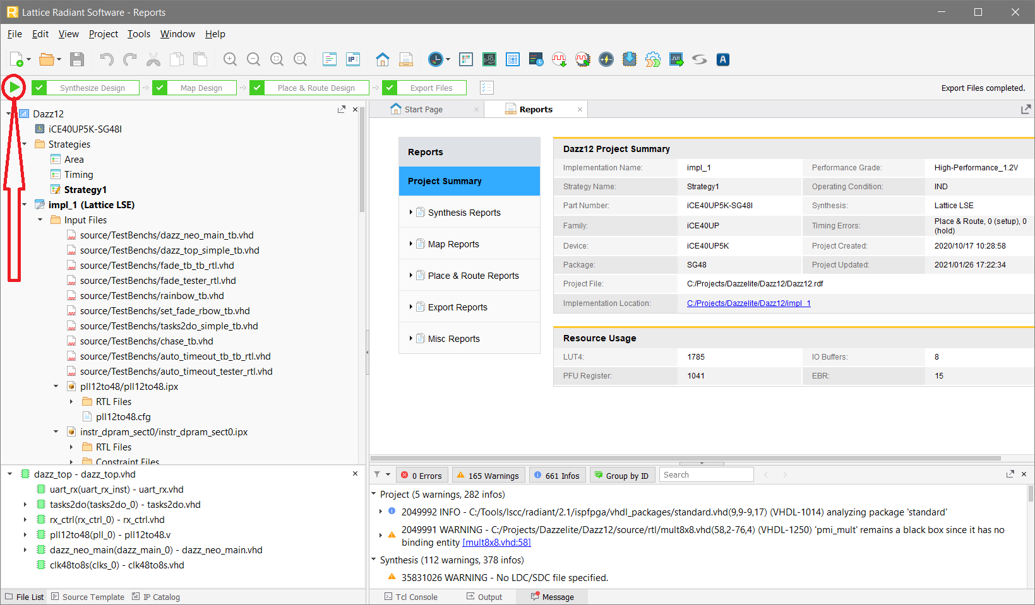

Figure : Run All

# Custom Displays

A great way to get started with making your own custom displays is to build new display instruction sets. One doesn’t need to know anything about FPGAs or software to do this. Use the supplied “Dazzelite_Instruction” spreadsheet to create each instruction. Use a text editor to combine the new instructions into a set of instructions. Refer to the supplied example display instruction sets, in the “Patterns” folder, to see how this looks. Remember to end each instruction set with the Finish instruction!

There are 4 memories in Dazzelite, each contain one display pattern. They are selected via the pattern pushbutton switch. Each memory can be loaded with a new pattern by double clicking on inst_dpram_sect0, 1, 2 or 3 as shown in Figure 2.

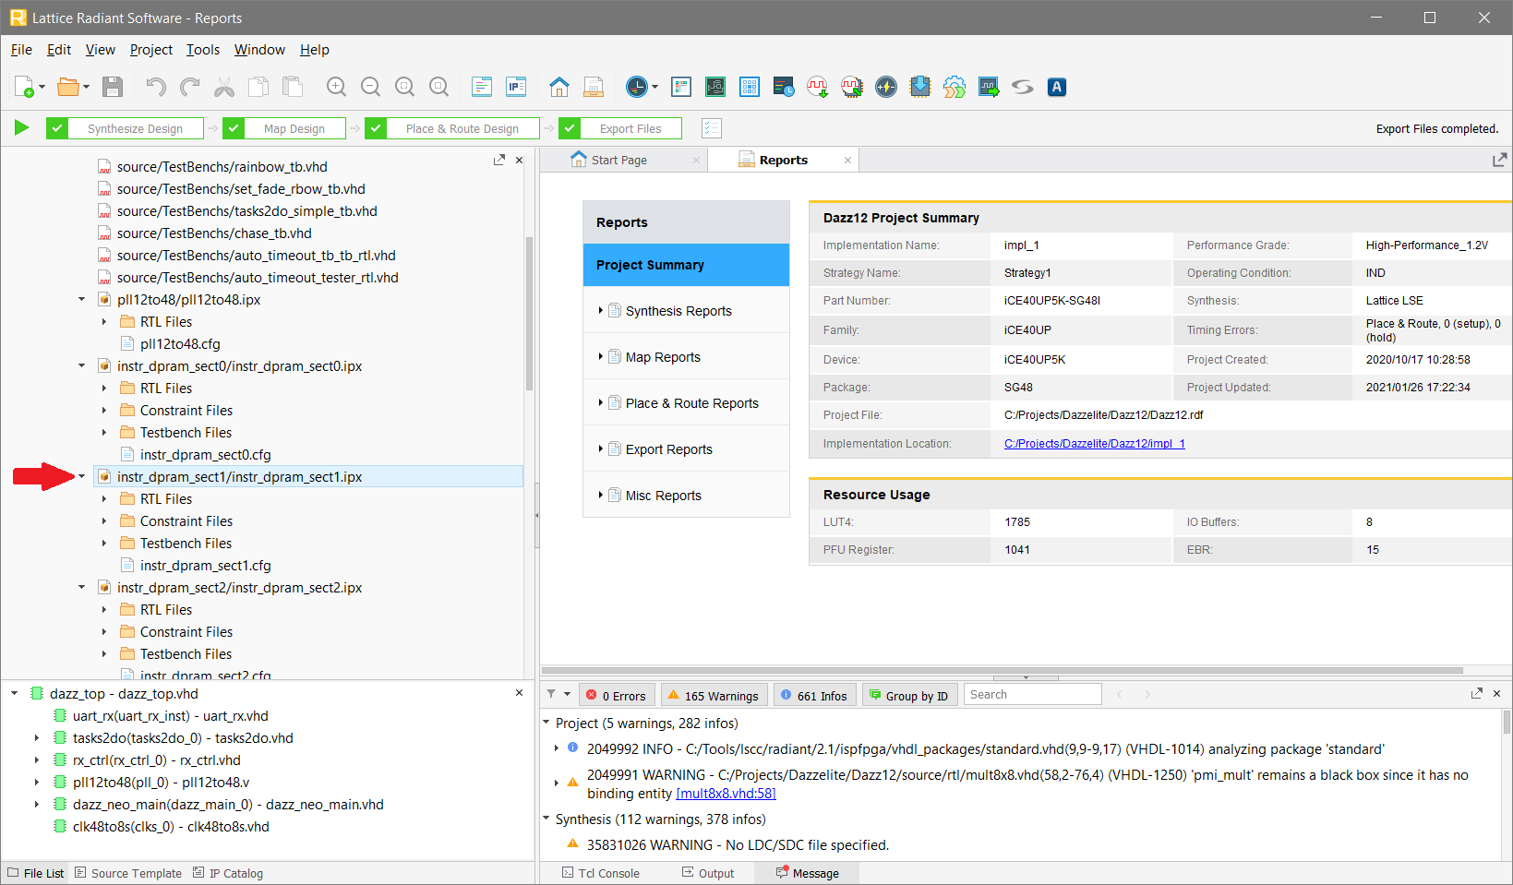

Figure 2: Changing Display Patterns

Replace the current instruction set with your new instruction set by clicking on “…” and navigating to that instruction as highlighted in Figure 3.

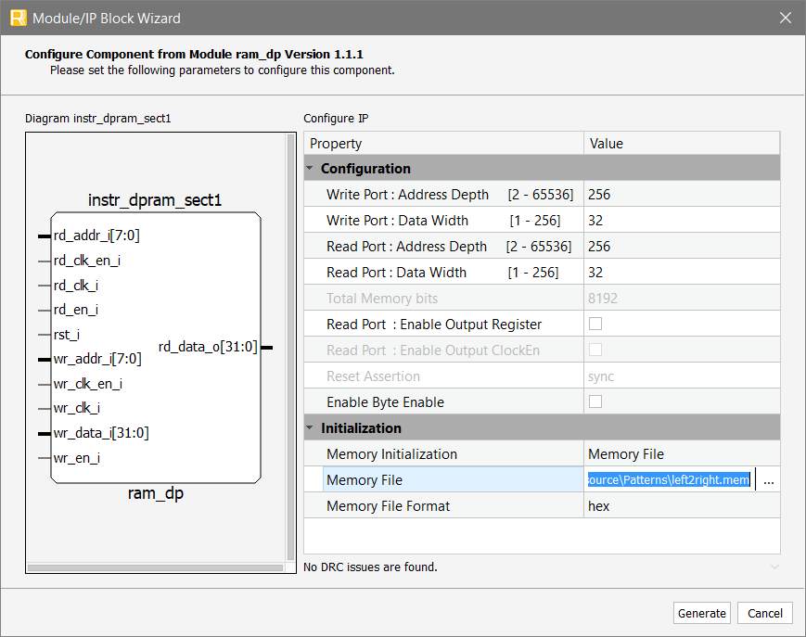

Figure 3: Replacing Display Pattern

Click in the “Generate” button (at the bottom of the window) to replace the display pattern. After that completes, re-build the design as outlined in the Building the Design section.

# Programming Dazzelite

Dazzelite can be programmed from the Radiant program or via a standalone programmer.

## Programmer Access Through Radiant

From Radiant, click on the programming icon as shown in Figure 4.

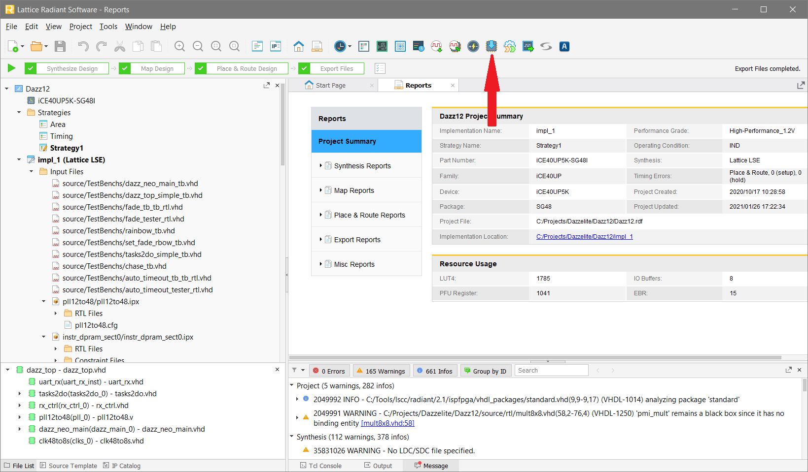

Figure 4: Programming Icon

## Standalone Programmers

There are many programmers that can be used to program Dazzelite. One is the Radiant [Programmer Standalone](https://www.latticesemi.com/Products/DesignSoftwareAndIP/FPGAandLDS/Radiant) and another is the Diamond [Programmer Standalone](http://www.latticesemi.com/en/Products/DesignSoftwareAndIP/ProgrammingAndConfigurationSw/Programmer.aspx#_20C94305815A4B3AAAFEA8B83943B751)). They’re both very similar.

## Programming Steps

The following steps can be used with the Radiant Programmer (either via Radiant or standalone) to program Dazzelite. The Diamond Programmer steps may be slightly different.

1. Connect the micro USB port on the UPDuino v3.0 to your PC

2. Open the Radiant Programmer

3. Click `Detect Cable` then `OK`

4. After scanning, select `Generic JTAG Device` and `Select iCE40 UltraPlus`

5. Under `Device` click iCE40UP3K and change it to iCE40UP5K

6. Under `Operation` double click `Fast Program` and change `Target Memory: ` to `External SPI Flash Memory`

7. Select your `*.hex` programming file under `Programming file`.

8. Configure the following `SPI Flash Options`

a. Winbond

b. W25Q32JV

c. 208mil 8-pin SOIC

9. Click `Load from File` under `SPI Programming` to get load size

10. Click OK

11. Click `Run` -> `Program Device`

# Instructions

The Dazzelite_Instruction spreadsheet provides an easy way to create instructions. It allows instructions to be build using decimal number and automatically provides the hexadecimal value (of the instruction) needed by the FPGA. Optionally, a detailed look at each bit, in each instruction, is provided in the rest of this section.

As previously noted, there are up to 16 possible instructions. Some are specifically tailored for the RGB LED ring. Instructions are 32-bits long. All instructions start with a command. Some commands are followed by additional fields. A detailed description of each instruction is presented in the following sections. Note all bits of the instructions are zeroed at powerup unless otherwise noted.

## Instruction 0: Blackout Display

Blackouts the entire display.

|  |  |  |  |  |  |
| --- | --- | --- | --- | --- | --- |
| 31 28 | 27 |  |  |  | 0 |
| CMD0 | Unused | Unused | Unused | Unused | Unused |

|  |  |  |
| --- | --- | --- |
| **Bits** | **Name** | **Function** |
| [31:28] | CMD0 | Blackouts all the LEDs in the string(s). All bits must be zero. |
| [27:0] | Unused | Not defined |

## Instruction 1: Delay

Adds a programmable time delay. Each additional count adds 5.12 mSeconds. The maximum count is 255 (0xFF). A count a zero creates a random delay.

|  |  |  |  |  |  |
| --- | --- | --- | --- | --- | --- |
| 31 28 | 27 20 | 19 |  |  | 0 |
| CMD1 | DLY | Unused | Unused | Unused | Unused |

|  |  |  |
| --- | --- | --- |
| **Bits** | **Name** | **Function** |
| [31:28] | CMD1 | Programmable delay. Value = 1 |
| [27:20] | DLY | Delay count. Max = 255 (0xFF). All zeros create a random count. |
| [19:0] | Unused | Not defined |

## Instruction 2: Finish

All instruction sets must end with a finish command!

|  |  |  |  |  |  |
| --- | --- | --- | --- | --- | --- |
| 31 28 | 27 |  |  |  | 0 |
| CMD2 | Unused | Unused | Unused | Unused | Unused |

|  |  |  |
| --- | --- | --- |
| **Bits** | **Name** | **Function** |
| [31:28] | CMD2 | Informs the FPGA that the present instruction set is finished. Value = 2 |
| [27:0] | Unused | Not defined |

## Instruction 3: Set Random LED

Used to set one LED at a random location/address and/or color. The random color is selected from the 16 colors in the color palette (see Instruction 9: Set Color Palette).

|  |  |  |  |  |  |
| --- | --- | --- | --- | --- | --- |
| 31 28 | 27|26| 25 20 | 19 12 | 11 |  | 1 | 0 |
| CMD3 | U | R | ADDR | BRITE | Unused | Unused | Unused|N |

|  |  |  |
| --- | --- | --- |
| **Bits** | **Name** | **Function** |
| [31:28] | CMD3 | Sets one LED. Value = 3 |
| [27] | U | Unused, not defined |
| [26] | R | Random LED address  0 = bits [25:0] specify address of LED  1 = random LED address generated |
| [25:20] | ADDR | Specific LED address when [26] = 0. Values 0 to 63 (0x3F) |
| [19:12] | BRITE | Set the brightness of the LED. Values 0 to 255 (0xFF) |
| [11:1] | Unused | Not defined |
| [0] | N | 0 = use the same color as used in the last CMD3. That color was the one last selected from the color palette.  1 = use the next color in the color palette. |

## Instruction 4: Set LED

Used to set one LED’s address and color.

|  |  |  |  |  |  |
| --- | --- | --- | --- | --- | --- |
| 31 28 | 27 26 | 25 20 | 19 12 | 11 8 | 7 4 | 3 0 |
| CMD4 | U | ADDR | BRITE | BLUE | GREEN | RED |

|  |  |  |
| --- | --- | --- |
| **Bits** | **Name** | **Function** |
| [31:28] | CMD4 | Sets one LED. Value = 4 |
| [27:26] | U | Unused, not defined |
| [25:20] | ADDR | Specific LED address. Values 0 to 63 (0x3F) |
| [19:12 | BRITE | Set the brightness of the LED. Values 0 to 255 (0xFF) |
| [11:8] | BLUE | Sets the amount of blue. Value 0 to 15 (0xF) |
| [7:4] | GREEN | Sets the amount of green. Value 0 to 15 (0xF) |
| [3:0] | RED | Sets the amount of red. Value 0 to 15 (0xF) |

## Instruction 5: Chase

Adds an offset to all LED addresses. Increments or decrements that address along with their brightness and color. The offset wraps around at maximum numbers of LEDs per string.

|  |  |  |  |  |  |
| --- | --- | --- | --- | --- | --- |
| 31 28 | 27 26 | 25 20 | 19 14|13|12 | 11 |  | 0 |
| CMD5 | U | SIZE | Unused | Z | ID | Unused | Unused | Unused |

|  |  |  |
| --- | --- | --- |
| **Bits** | **Name** | **Function** |
| [31:28] | CMD5 | Increments or decrements every LED’s address by the offset size. Value = 5 |
| [27:26] | U | Not defined |
| [25:20] | SIZE | Offset size. A size of 0 = 1. All others = number entered |
| [19:14] | Unused | Not defined |
| [13] | Z | 0 = do not zero LEDs address offset  1 = zeros LEDs address offset (ID value ignored) |
| [12] | ID | 0 = decrement offset  1 = increment offset |
| [11:0] | Unused | Not defined |

## Instruction 6: Left to Right and Right to Left

Two strings of colors start at the top of the display and make there way to the bottom then back up to the top. As they merge (at the bottom), the resulting color is displayed.

|  |  |  |  |  |  |
| --- | --- | --- | --- | --- | --- |
| 31 28 | 27 23 | 22 20 | 19 12 | 11 |  | 0 |
| CMD6 | Unused | QTY | BRITE | Unused | Unused | Unused |

|  |  |  |
| --- | --- | --- |
| **Bits** | **Name** | **Function** |
| [31:28] | CMD6 | Runs the algorithm. Value = 6 |
| [27:23] | Unused | Not defined |
| [22:20] | QTY | Quantity of lights, 1 to 8 per side |
| [19:12] | BRITE | Set the brightness of the LED. Values 0 to 255 (0xFF) |
| [11:0] | Unused | Not defined |

## Instruction 7: Fade In and Out

Fades all LEDs brightness. Increments and then decrements all LEDs brightness.

|  |  |  |  |  |  |
| --- | --- | --- | --- | --- | --- |
| 31 28 | 27 26|25 24|23 22|21 20 | 19 13|12 | 11 |  | 0 |
| CMD7 | U | LLIM| ULIM| SPD | Unused | EF | Unused | Unused | Unused |

|  |  |  |
| --- | --- | --- |
| **Bits** | **Name** | **Function** |
| [31:28] | CMD7 | Increments or decrements every LED’s address by one. Value = 7 |
| [27:26] | U | Unused, not defined |
| [25:24] | LLIM | Limits how low the brightness value can go |
| [23:22] | ULIM | Limits how high the brightness value can go |
| [21:20] | SPD | Speeds up the incrementing and decrementing |
| [19:13] | Unused | Not defined |
| [12] | EF | 0 = disable fading once decrement reaches its lowest value  1 = enables fading starting at its lowest value |
| [11:0] | Unused | Not defined |

## Instruction 8: Loop

Loop the previous x number of instructions.

|  |  |  |  |  |  |
| --- | --- | --- | --- | --- | --- |
| 31 28 | 27 20 | 19 12 | 11 |  | 0 |
| CMD8 | LOOPS | QTY | Unused | Unused | Unused |

|  |  |  |
| --- | --- | --- |
| **Bits** | **Name** | **Function** |
| [31:28] | CMD8 | Repeats previous instructions. Value = 8 |
| [27:20] | LOOPS | Sets the number of times a loop is executed. A value of 255 (0xFF) is a continuous loop. |
| [19:12] | QTY | Quantity of instruction to repeat. Subtract the start instruction from the loop instruction line number. |
| [11:0] | Unused | Not defined |

## Instruction 9: Set Color Palette

Storage location for 16 definable colors. Used in conjunction with Instruction 3: Set Random LED. A set of predefined colors are loaded at powerup. Use this instruction to change them.

|  |  |  |  |  |  |
| --- | --- | --- | --- | --- | --- |
| 31 28 | 27 24 | 23 20 | 19 12 | 11 8 | 7 4 | 3 0 |
| CMD9 | Unused | CNUM | Unused | BLUE | GREEN | RED |

|  |  |  |
| --- | --- | --- |
| **Bits** | **Name** | **Function** |
| [31:28] | CMD9 | Sets one LED. Value = 9 |
| [27:24] | Unused | Not defined |
| [23:20] | CNUM | Specific palette address. Values 0 to 15 (0xF) |
| [19:12] | Unused | Not defined |
| [11:8] | BLUE | Sets the amount of blue. Value 0 to 15 (0xF) |
| [7:4] | GREEN | Sets the amount of green. Value 0 to 15 (0xF) |
| [3:0] | RED | Sets the amount of red. Value 0 to 15 (0xF) |

## Instruction 10 (0xA): Reserved

Do not use. It’s used in other versions of this project.

|  |  |  |  |  |  |
| --- | --- | --- | --- | --- | --- |
| 31 28 | 27 |  |  |  | 0 |
| CMD10 | Unused | Unused | Unused | Unused | Unused |

|  |  |  |
| --- | --- | --- |
| **Bits** | **Name** | **Function** |
| [31:28] | CMD10 | Reserved. Value = 10 (0xA) |
| [27:0] | Unused | Not defined |

## Instruction 11 (0xB): Rainbow

Transitions through the 12-bit color spectrum.

|  |  |  |  |  |  |
| --- | --- | --- | --- | --- | --- |
| 31 28 | 27 | 13|12 | 11 |  | 0 |
| CMD11 | Unused | Unused |ER | Unused | Unused | Unused |

|  |  |  |
| --- | --- | --- |
| **Bits** | **Name** | **Function** |
| [31:28] | CMD11 | Increments or decrements every LED’s address by one. Value = 11 (0xB) |
| [27:13] | Unused | Not defined |
| [12] | ER | 0 = disable the transitions  1 = enables the transitions |
| [11:0] | Unused | Not defined |

## Instruction 12 (0xC): Reserved

Do not use. It’s used in other versions of this project.

|  |  |  |  |  |  |
| --- | --- | --- | --- | --- | --- |
| 31 28 | 27 |  |  |  | 0 |
| CMD12 | Unused | Unused | Unused | Unused | Unused |

|  |  |  |
| --- | --- | --- |
| **Bits** | **Name** | **Function** |
| [31:28] | CMD12 | Reserved. Value = 12 (0xC) |
| [27:0] | Unused | Not defined |

## Instruction 13 (0xD): Automatic Timeout

Automatically turns the LEDs on and off according to the following settings. The instruction set in use before the time “off” will resume once the time “on” is attained. One should set this up before issuing display instructions.

|  |  |  |  |  |  |
| --- | --- | --- | --- | --- | --- |
| 31 28 | 27 25 | 24 20 | 19 17 | 16 12 | 11 | 5 | 4 0 |
| CMD13 | Unused | HON | Unused | HOFF | Unused | Unused | HDLY |

|  |  |  |
| --- | --- | --- |
| **Bits** | **Name** | **Function** |
| [31:28] | CMD13 | Sets one LED. Value = 13 (0xD) |
| [27:25] | Unused | Not defined |
| [24:20] | HON | Hours on. “0” is always on. Values 0 to 31 (0x1F) |
| [19:17] | Unused | Not defined |
| [16:12] | HOFF | Hours off. “0” is once off stay off. Value 0 to 31 (0x1F) |
| [11:5] | Unused | Not defined |
| [4:0] | HDLY | Hours delayed (off). Value 0 to 31 (0x1F) |

## Instruction 14 (0xE): Unused

Available for a new instruction.

|  |  |  |  |  |  |
| --- | --- | --- | --- | --- | --- |
| 31 28 | 27 |  |  |  | 0 |
| CMD14 | Unused | Unused | Unused | Unused | Unused |

|  |  |  |
| --- | --- | --- |
| **Bits** | **Name** | **Function** |
| [31:28] | CMD14 | Unused but available. Value = 14 (0xE) |
| [27:0] | Unused | Not defined |

## Instruction 15 (0xF): Unused

Available for a new instruction.

|  |  |  |  |  |  |
| --- | --- | --- | --- | --- | --- |
| 31 28 | 27 |  |  |  | 0 |
| CMD15 | Unused | Unused | Unused | Unused | Unused |

|  |  |  |
| --- | --- | --- |
| **Bits** | **Name** | **Function** |
| [31:28] | CMD15 | Unused but available. Value = 15 (0xF) |
| [27:0] | Unused | Not defined |

# Code Base

The code base consists of mostly VHDL modules, some Verilog modules, instantiated and inferred IPs. There are 5 instantiated cores.

One instantiated core is a PLL (Phase Lock Loop). It’s used for creating a 48 MHz clock from the 12 MHz oscillator on the daughter board. A separate module divides the 48 MHz clock down to the 8 MHz and 800 kHz clocks used in the design. The majority of the design runs at 800 kHz.

The 4 remain cores are 256 x 32 memories. Each core holds an instruction set for a display pattern.

# Block Diagram of Dazzelite Code

